Marine Pests!

Activity Book

What are marine pests?
Marine pests are plants animals there aren’t native to our waters. They can include seaweeds, mussels, crabs and seastars. Marine pests can reproduce quickly and rapidly spread to new areas where they compete with native species by preying upon them, and outcompete them for space, light, food. They can also introduce diseases and parasites to our native species.
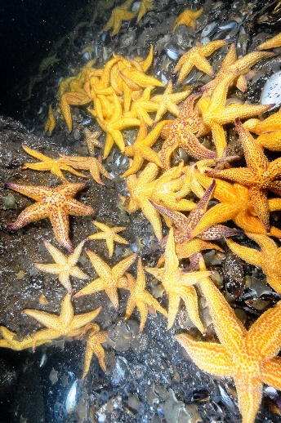

How do marine pests get here?
Marine pests are often introduced by the movements of international and domestic shipping. Once here, smaller recreational boats can spread marine pests to new areas along the coast.

How can we manage marine pests?
Everyone can help manage marine pests, even you! The most important things we can do is to keep an eye out for anything unusual when we’re enjoying ourselves at the beach. If you see something unusual, report it.

How can I help?
Help protect our marine environment and biodiversity from marine pests
If you see something unusual, found or sighted in Victoria then report it to Agriculture Victoria
Download the Marine Pest Deck and keep an eye out for high-risk marine pests - Marine pest deck: Invasive species guide | Marine pests | Biosecurity | Agriculture Victoria

Keep an eye out for these
Invasive seasquirts or ascidians are not found in Victoria. They can overgrow and smother native species and found marine equipment.
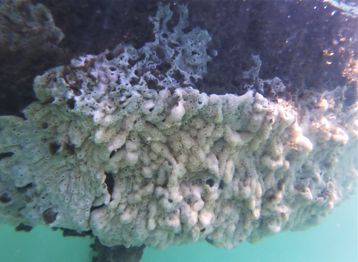
Northern Pacific seastars are established in Port Phillip Bay. They can produce up to 20 million eggs each year and feed on bivalve.
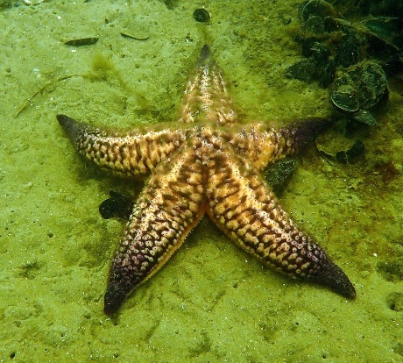
Wakame is an invasive seaweed that is found in Victoria. It can grow on boats and be transported around the coast.
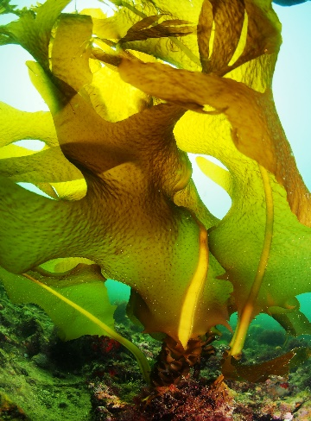

high-risk marine pests!
Asian paddle crabs are not found in Victoria. An aggressive species that can outcompete native species and introduce diseases.
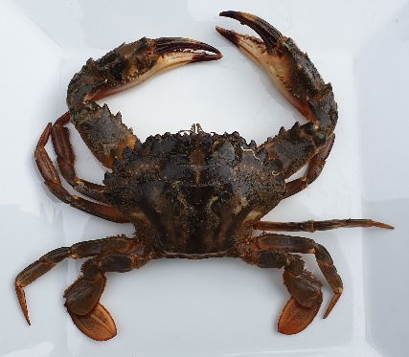
Asian shore crabs are found in Port Phillip Bay. They can outcompete native species and prey on crabs and shellfish.
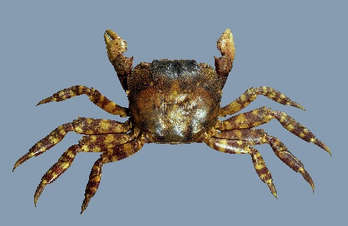
Brown mussels are not present in Victoria. They can displace native species and found wharf pylons, marinas and aquaculture gear.
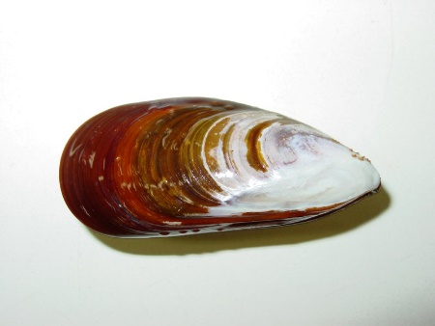
Chinese mitten crabs are not found in Victoria. Their burrowing can damage riverbanks and shorelines.
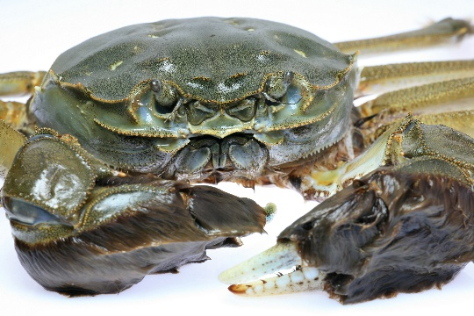

Find the hiding marine pests
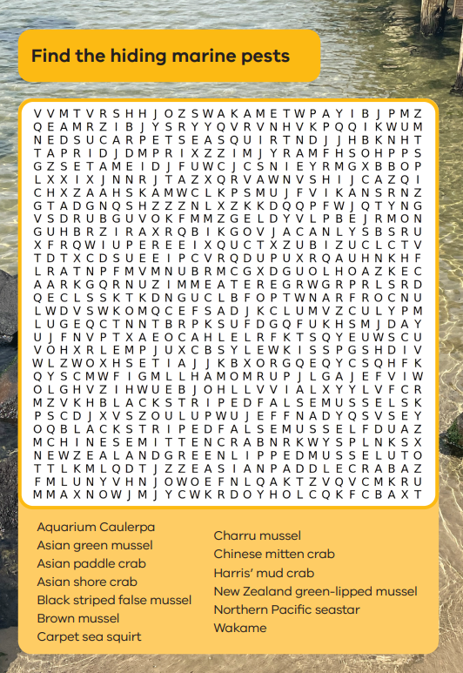

Connect the dots to find the pests
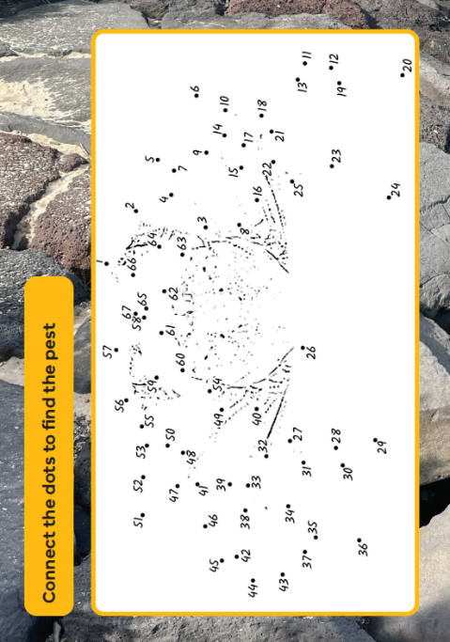

Circle the marine pests and colour in the picture
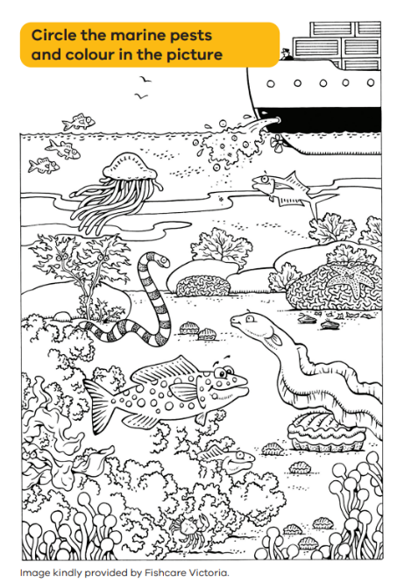

Help find the Asian shore crab!
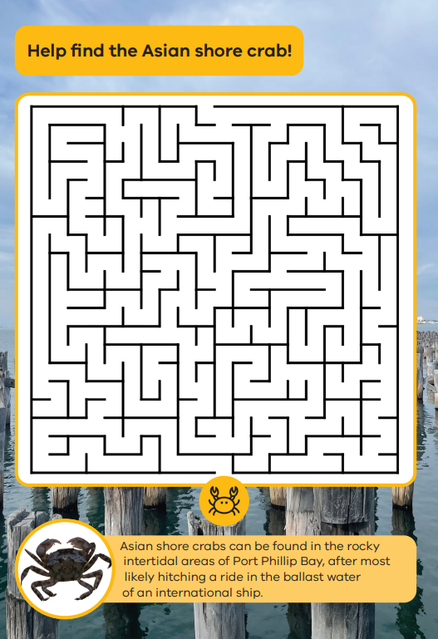
Asian shore crabs can be found in the rock intertidal areas of Port Phillip Bay after most likely hitching a rode in the ballast water of an international ship.
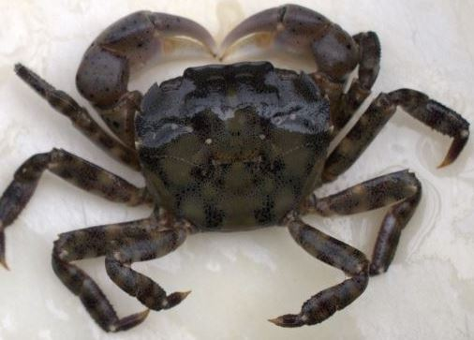

Marine pest crossword
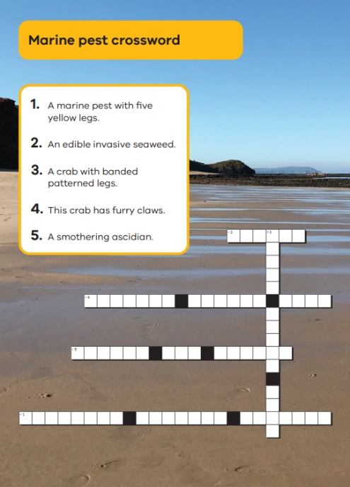
Unscramble the letters to reveal the marine pests
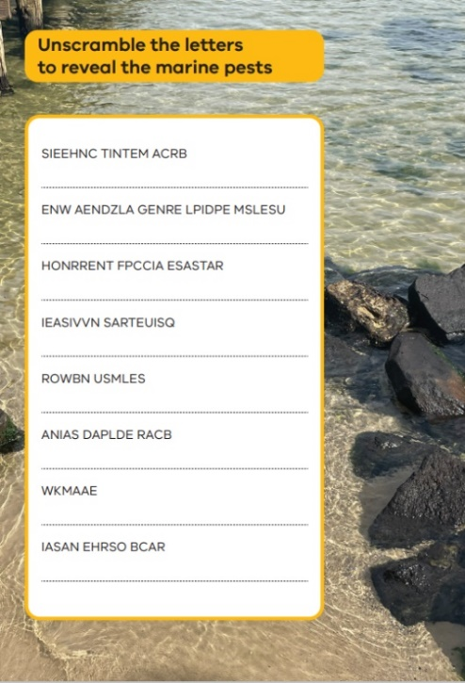

Interested in learning more?
The following websites have lots of great information on marine pests and the marine environment
Visit www.vic.gov.au/marine-pests
Visit www.visitsealife.com/melbourne/schools

